Two Dimensional Array

The matrix Operation we done is one of the best suit for 2d array .

Now lets create a matrix of 4 X 5 .

It means 4 rows 5 column

= [ 10 20 30 40 50

60 70 80 90 100

110 120 130 140 150

160 170 180 190 200 ]

This is we called as 2d Array

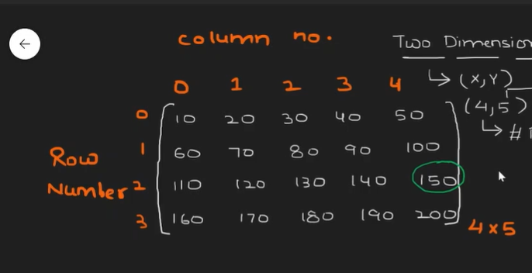

If we want to find the particular element ex : 150

If It is 0ne dimensional array (1d)

* Base Address + (Location index - Starting Index) \* size of Datatype

So if we want to go to 150 element we use Array[2][4] = 150

🡪2 is a row ; 4 is a column



So if want to find the memory address of a[2][4]

Base Address 🡪 1000 ; Size is 2 bytes

The formula is :

Base Address + [ (which row – starting row ) \* Total no column + (which column – starting column ) ] \* size of element

Base Address 🡪 1000 ; Which Row(l) 🡪 2 ; Starting Row(lbr) 🡪0 ; no of column 🡪 5 ; Which Column(j)(lbc) 🡪 4 ; Starting Column 🡪 0 ; Size of the data type 2 ;

= 1000 + [(2 – 0) \* 5 + (4 – 0)]\* 2

= 1000 + [(10) +(4)] \* 2

= 1000 + [ 14 ] \* 2 🡪 14 means after 14 element this item is present

= 1028 is the Memory Address of arr[2][4]

* Generic Formula for 2d Array 🡺 Base Address + [(I –lbr) \* nc +(j –lbc)] \* size
* Generic formula for 1d Array 🡪 Base Address + (Location index - Starting Index) \* size of Datatype

In Our Memory Array is Stored in a Row Major Order

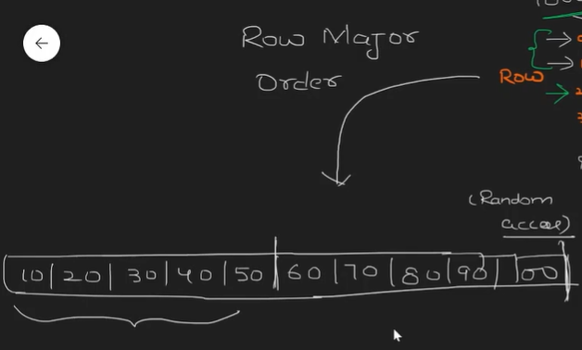

Any Programming Language array is Stored in a Row Major Order